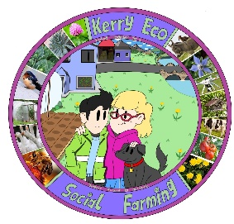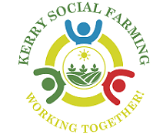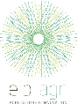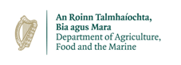
Author(s): Luke Myers
Kerry Eco-Social Farming – an EIP integrated within a Voluntary Model of Social Farming, addressing biodiversity, inclusion and accessibility on farms in Kerry.
Inclusive management of nature in the Irish farming landscape
Overview – The Kerry Eco-Social Farming European Innovation Partnership (KESF EIP) was a nature-based project, funded by the Department of Agriculture, Food and the Marine through the European Innovation Partnership fund. The project was integrated into a voluntary model of social farming, Kerry Social Farming (KSF), a community-based project which links up ‘at risk’ groups to local farmers. The project caters to people with additional needs, acquired brain injuries, utilising specific mental health services to link up with local volunteer farmers across the county in order to provide inclusion and accessibility on farms. The KESF EIP was a single year Call5 EIP which focused on enhancing the social farming experience for host farmers and participants through the provision of funding, training and guidance on biodiversity and nature-based action.
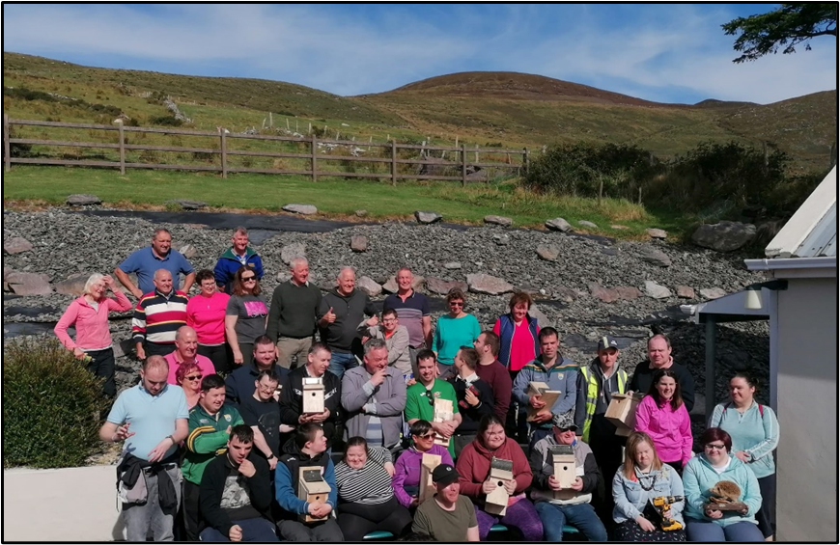
Background – KESF EIP is built on inclusivity, integration and accessibility, with the project’s main finding being that more science and nature-based schemes must be developed for disadvantaged and ‘at risk’ groups across the country, particularly in rural areas. During this project, a number of actions were undertaken by host farmers and social farming participants across twenty-six farms over the length and breadth of Kerry. The actions prescribed to host farms were relatively simplistic in nature, along with having a positive impact on local biodiversity, for tangible scope in terms of public relations and also to adequately engage and ‘marry-into’ the weekly social farming activities. The action types which we’ll be discussing in this case study include; bird box development, cleaning and installation, solitary bee nesting habitat development and wildflower area development.
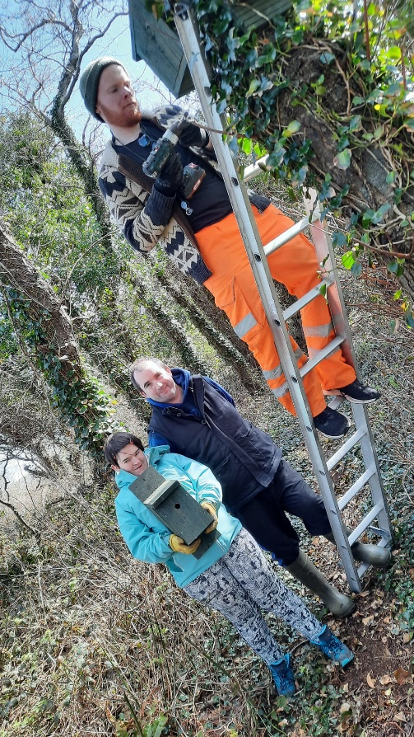
KSF, the parent project from which KESF EIP was based, is managed by South Kerry Development Partnership (SKDP), and North East West Kerry Development (NEWKD) are among the project partners. As a result of this key involvement of Local Development Companies, KESF has been able to access community groups, organisations and events associated with each of these, assisting with project development, community benefit and engagement. KESF EIP acquired the skillsets of both Tralee and Killarney Men’s Shed groups, and engaged them to develop bird nesting, bat roosting and solitary bee cavity boxes for the project. Along with this, an event, centred around bird box development, was delivered in co-ordination with the Kerry Biosphere Reserve.
The development of solitary bee nesting habitats, as noted within the All-Ireland Pollinator Plan, was identified as a potential action which could be completed by host farmers and asocial farming participants together. The simple task of using a shovel or bucket to expose vertical edges of south facing dry slope, followed by weeding as management, was noted as being achievable. This action was further propelled into popularity amongst farmers and participants when a number of interesting solitary bee species were identified during one of the bioblitz events.
The management of areas of disused ground for wildflowers also proved popular. With the simple steps of a single cut per year alone and not re-seeding or digging, host farmers and social farming participants will be able to enjoy naturally created wildflower areas on their farms for years to come. This method was also adopted from the All-Ireland Pollinator Plan and utilises the seedbank, which is abundant in all soils in order to develop naturally occurring native and local providence wildflowers suitable for local pollinating insects.
Goals – The aim of KESF EIP was to encourage host farmers and participants to increase the area managed for nature on their farms, through habitat creation, management and improvement. The project’s key performance indicators (KPIs) were specifically designed to maximise the benefits to nature, along with having the abilities of host farmers and participants in mind.
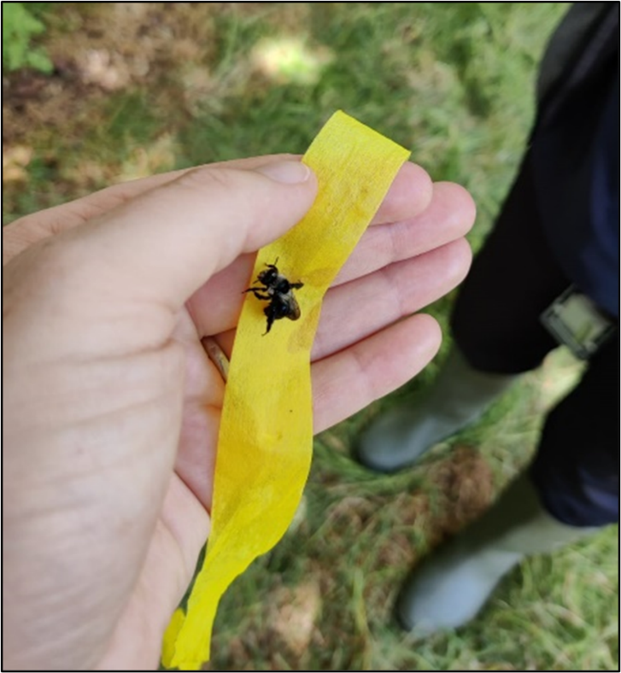
Approach – A multitude of meitheal working groups, training courses and practical engagement sessions on farms allowed for the identification and demonstration of action management to those involved. It was noted that, host farmers and social farming participants engaged more when actions were targeted more to a specific species which they already knew. As a result, different styles of bird box were developed, as per Bird Watch Ireland guidelines. Bird boxes associated with; Blue tit/ Meantán gorm (Cyanistes caeruleus), Great tit/ Meantán mór (Parus major), Starling/ Druid (Sturnus vulgaris), Robin/ Spideog (Erithacus rubecula), and Barn owl/ Scréachóg reilige (Tyto alba) were distributed. Along with this, bird box developments ‘kits’ were also formed by the men’s shed groups in order to provide host farmers and social farming participants with the wood, hardware and opportunity to develop their very own bird and bat boxes. As a result of this, actions including the development of wildflower areas and management of solitary bee nesting habitats proved to be less popular – potentially due to the awareness and commonality of birds as opposed to solitary bees.
Results – In total across all 26 participating host farms; 95 bird & bat boxes were supplied, 100 solitary bee nesting habitats developed, 3.4 areas were managed for wildflowers, 15 acres of invasive species managed (year 1 management), 4 wildlife ponds developed, 2 km of hedgerow either developed or improved, 8 small mammal wood piles & areas developed/ managed, 1 cutover bog drain blocked, 10 tree veteranisation features developed, 2 viviparous lizard refuges installed, 1 section of drystone wall improved, 1 section of sand martin habitat protected and 1 section of 1m river buffer zone developed.
“I enjoyed the training courses and meitheals, getting to interact with other host farmers was the main benefit of the project.” – Host Farmer 10
“I liked looking at nature” – Social Farming Participant 10
“I enjoyed meeting other farmers across Kerry” – Host Farmer 1
“I like looking for nature on the farm” – Social Farming Participant 6
Learnings –
The involvement of all peoples within a project is key. The scope of all steps within a project can be altered in order to facilitate everyone. Just like the actions within KESF EIP were specifically designed with the social farming participants in mind, accommodations can be made across society to allow for more inclusion and a greater sense of community.
Resources –
Whelan, R. (2021). Build a Nest Box for Birds and Biodiversity in Your Garden This Spring. [online] BirdWatch Ireland. Available at: https://birdwatchireland.ie/build-nest-boxes-for-birds-in-your-garden-this-spring/ [Accessed 17 Feb. 2023].
All-Ireland Pollinator Plan. (2017). All-Ireland Pollinator Plan» All-Ireland Pollinator Plan. [online] Available at: https://pollinators.ie/ [Accessed 17 Feb. 2023].

‌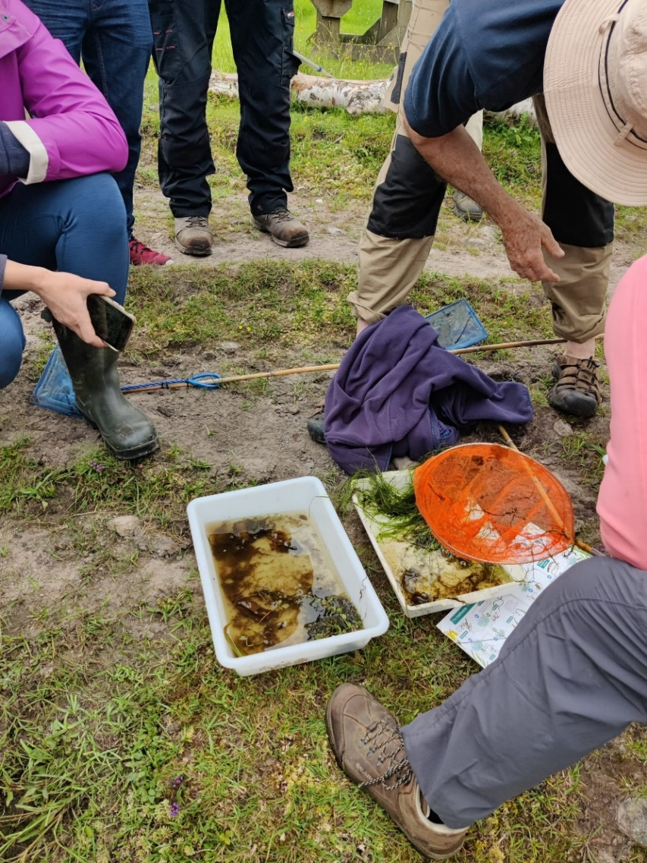

This project was funded by the Department of Agriculture, Food and the Marine under the European Innovation Partnership Fund.
